Ideation Phase
Brainstorm & Idea Prioritization Template

Date | 28 September 2026
Team ID | 6ab221fbe880316a482c6241
Project Name | Script-Controlled ACL – Restrict Record Access Based on Field Value
Maximum Marks | 4 Marks

Brainstorm & Idea Prioritization Template:
Brainstorming provides a free and open environment that encourages everyone within a team to participate in the creative thinking process that leads to problem solving. Prioritizing volume over value, out-of-the-box ideas are welcome and built upon, and all participants are encouraged to collaborate, helping each other develop a rich amount of creative solutions.
Use this template in your own brainstorming sessions so your team can unleash their imagination and start shaping concepts even if you're not sitting in the same room.

Step-1: Team Gathering, Collaboration and Select the Problem Statement
Team gathering | Team members meet online or in person and agree on the roles: facilitator, note taker and ideators.
Set the goal | Find the best way to restrict record access so that only EEE branch users can view the records.
Problem statement | How might we restrict record access in ServiceNow so that only users of the EEE branch can view the EEE records?
Time to prepare | 10 minutes to prepare, 1 hour to collaborate, 2-8 people recommended.

Key rules of brainstorming
Stay in topic | Encourage wild ideas
Defer judgment | Listen to others
Go for volume | If possible, be visual
Step-2: Brainstorm, Idea Listing and Grouping
Brainstorm: each team member writes down as many ideas as possible for the problem statement.

Person 1 | Use role-based ACL only | Script-controlled ACL that checks the user's branch | Create a separate table for each branch
Person 2 | Hide records with a UI policy | Before-query business rule to filter records
Person 3 | Domain separation for each branch | Group-based ACL condition for EEE
Person 4 | Reusable Script Include for the branch check | Log and notify on denied access

Group ideas: similar ideas are grouped under a theme.

Access control rules | Data separation | Filtering and UI | Support and reuse
Role-based ACL only | Separate table per branch | UI policy to hide records | Reusable Script Include
Script-controlled ACL on branch | Domain separation | Before-query business rule | Log and notify on denied access
Group-based ACL condition

Step-3: Idea Prioritization

Ideas are placed on a grid by how important they are and how feasible they are. Ideas in the top-right area are taken forward.
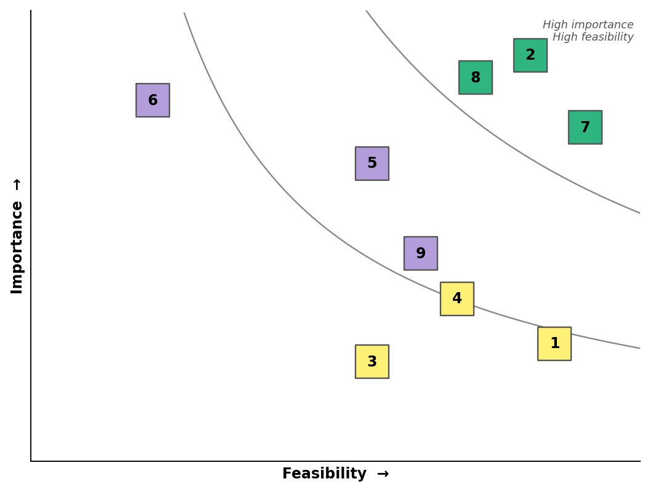
No. | Idea | Feasibility | Importance
1 | Role-based ACL only | High | Low
2 | Script-controlled ACL that checks the user's branch | High | High
3 | Separate table for each branch | Medium | Low
4 | UI policy to hide records | High | Low
5 | Before-query business rule | Medium | Medium
6 | Domain separation | Low | High
7 | Group-based ACL condition | High | High
8 | Reusable Script Include for the branch check | High | High
9 | Log and notify on denied access | Medium | Medium
Selected idea: Idea 2 (script-controlled ACL that checks the user's branch), supported by Idea 7 (group-based condition) and Idea 8 (reusable Script Include).

